NTNU Students Visits the College of Natural Sciences
The Department of Physics, College of Natural Sciences is hosting masters’ students from Norwegian University of Natural Sciences (NTNU) Norway (i.e. Alexander Bjaaen Steen, Chrstian Bogsnes, Oskar Stadaas Sjoegren and Even Ersdal Hansen) under the EnPe project which is based at NTNU. The project involves 4 African universities (Makerere University, Uganda; Mekele University, Eithopia; Eduardo Monde University, Mozambique and Dar es Salam University, Tanzania).
The EnPe project is coordinated by Professor Ole Jorgen Ngoal based at NTNU. The former beneficiaries of this project in the Department of Physics, Makerere University are Dr. Karidewa Nyeinga, who is the Principal Investigator (PI) of the project and Dr. Okello Denis.
The NTNU students will be here from 8th to 13th April 2018. They are going to set up a non electrical experiment that can be used for solar cooking at temperatures controlled by a Mechanical Thermostat. These started by giving a presentation on Monday 9th April 2018 at the Department of Physics and on 11th Feb 2018, they assembled the system which was tested on 12th April 2018 and this will be left at the department of Physics. The EnPe Norwegian students will leave the country back to NTNU on 13th April 2018.
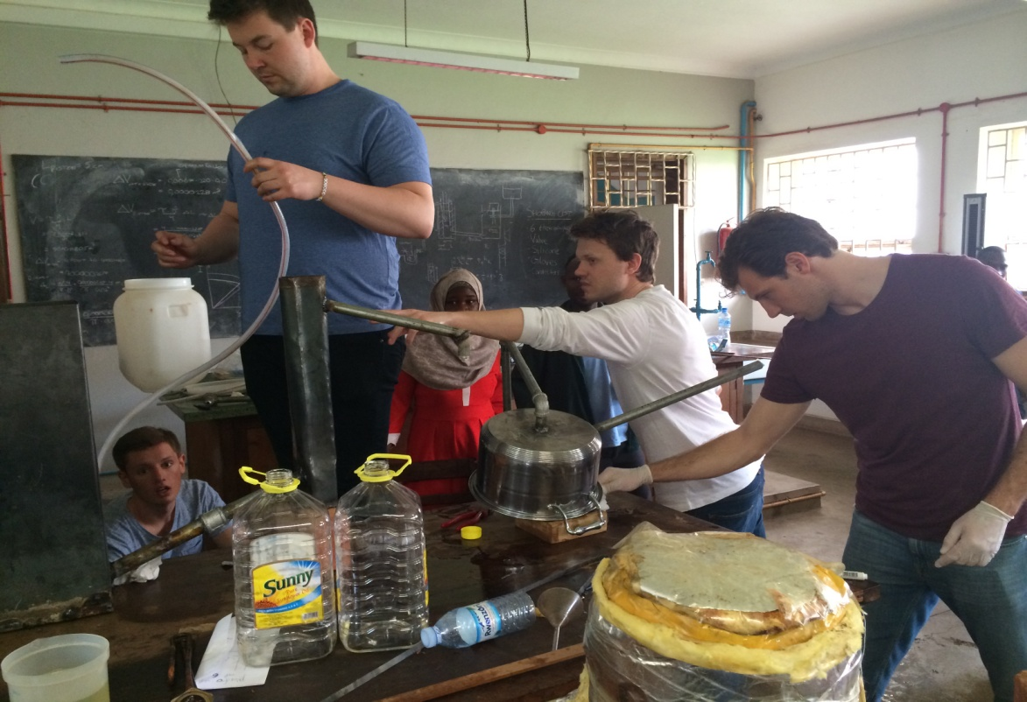
EnPe Norwegian Students assembling and testing the Mechanical Thermostat Experiment at the Department of Physics, College of Natural Sciences, Makerere University
The Norwegian Embassy gained interest in the project and has promised to spread it across schools in training students on how to cook using solar.
